CS 482 Homework 1 Talha Agcayazi

All code are in the Appendix.

Input Images:

img1.jpg:

Matlab Output: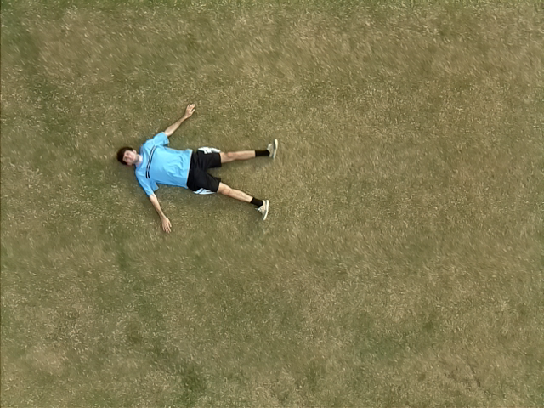

**Part1**

Filtering with Sobel only:

(these images were greyscaled before the edge detection operations)

After adding the 45 degree differential filter: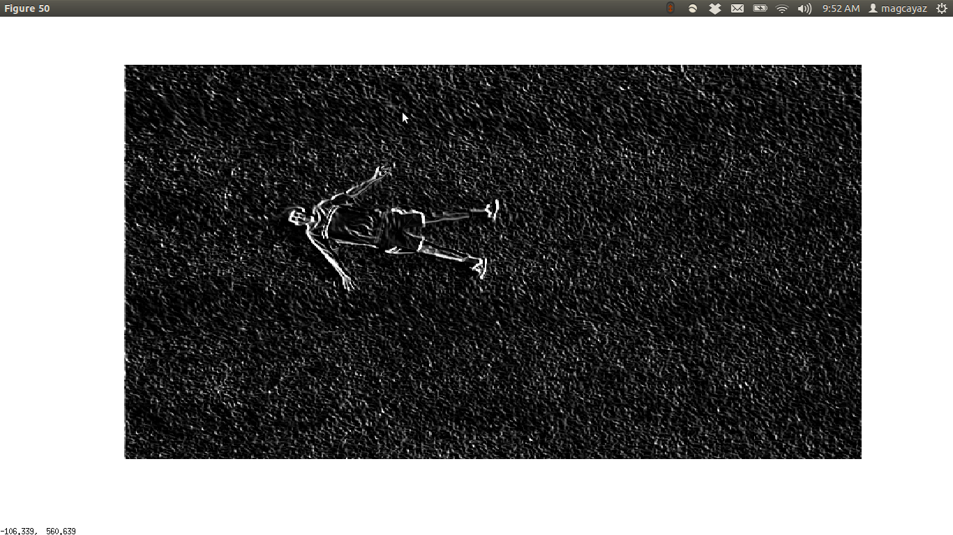

Although we get more edges we also get more noise in this example. We can filter out this noise easily with dilating and eroding. 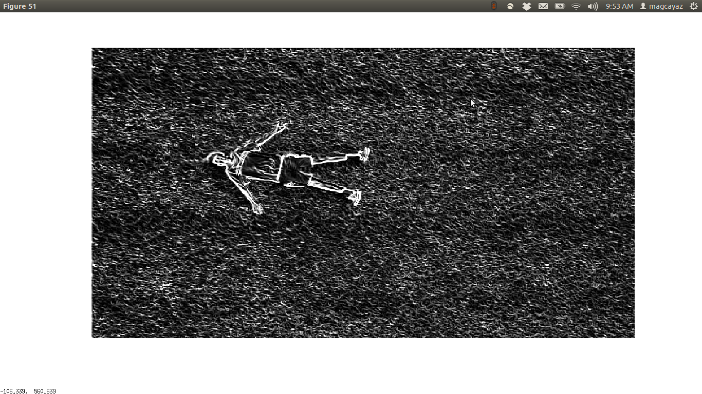

**Part2:**

Residual image (after running the box filter for 30 iterations)

Gaussian filter (same size as the box filter of 3x3)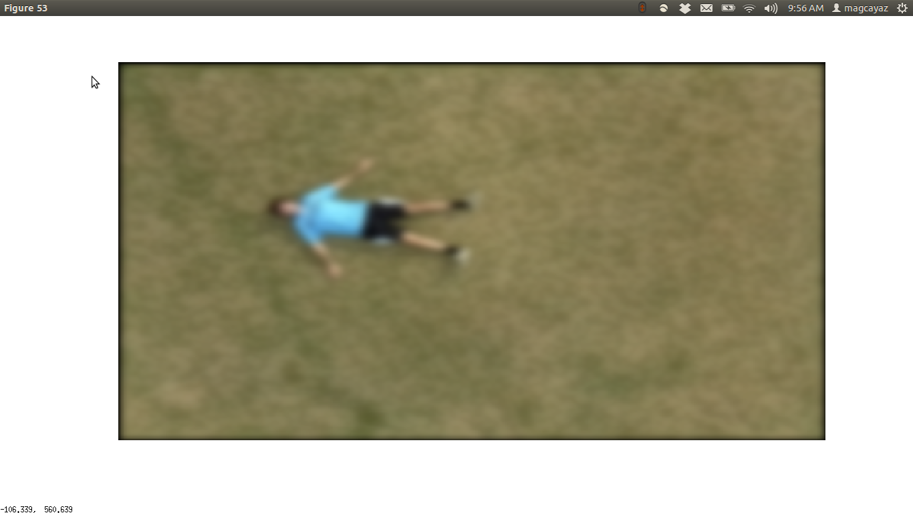

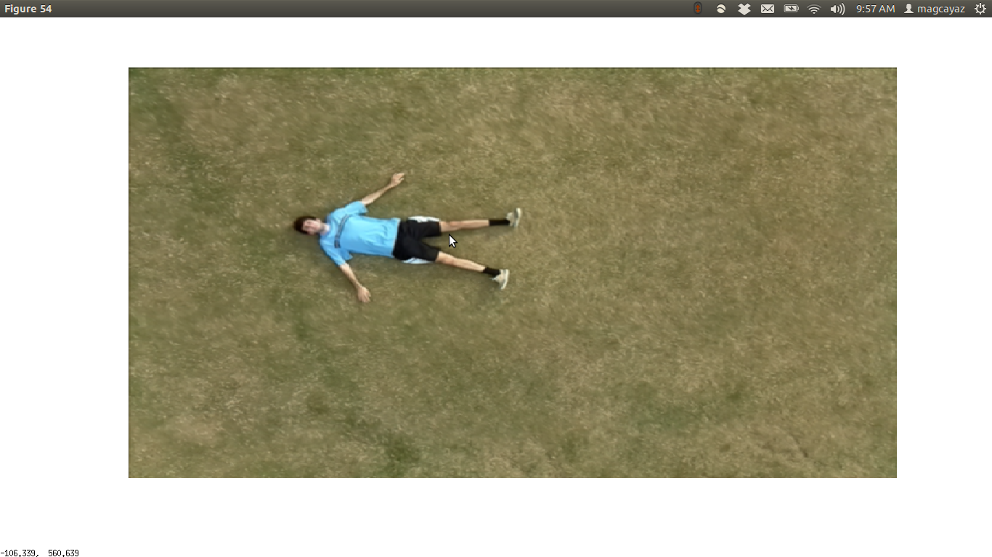

Gauss filter, instead of filtering everything with the same value like the box filter, filters the outer values more than the values that are closer.

radius of a gauss filter is 2k+1 sized.

So in my case the radius was 3

**Appendix**

**Matlab**

**Part 1;**

img1 = imread('img1.png');

%reference: http://stackoverflow.com/questions/25469203/how-can-i-improve-my-sobel-operator-edge-detection

grayImg = rgb2gray(img1);

kernelx = [-1, 0, 1;

-2, 0, 2;

-1, 0, 1];

kernely = [1, 2, 1;

0, 0, 0;

-1, -2, -1];

figure();

imshow(grayImg)

img1 = imfilter(grayImg, kernelx);

img2 = imfilter(grayImg, kernely);

%adding filtered image in x and y

img = img1+img2./2;

figure();

imshow(img)

%directional derivative 45 degrees

kerneldir = [2, 1, 0;

1, 0, -1;

0, -1, -2];

img3 = imfilter(grayImg, kerneldir);

imgFinal = (img3+img1+img2)./2;

figure();

imshow(imgFinal)

% without directional we miss some of the edges but with directional we get some much more noise.

**Part2**

img = imread('img1.png');

boxFilter= [1, 1, 1;

1, 1, 1;

1, 1, 1];

boxFilter = boxFilter./9;

gausImg = img;

figure();

imshow(img)

%run a filter

for i = 1:30

img = imfilter(img, boxFilter);

end

%plot final image;

figure();

imshow(img)

% see how it works with a gaussian filter

boxFilter= [1, 1, 1;

1, 4, 1;

1, 1, 1];

boxFilter = boxFilter./(sum(sum(boxFilter)));

img = imfilter(gausImg, boxFilter);

%plot final Gauss image;

figure();

imshow(img)

%Gauss filter, instead of filtering everything with the same value like the box filter,

% filters the outer values more than the values that are closer.

% radius of a gauss filter is 2k+1 sized.